Project 4: Non-linear tree allometry

Overview: In this project, we will implement a nonlinear model for tree height (H) versus trunk radius (R). This model involves a classical error-in-variables model for repeated observations of the “explanatory” covariate, R, with relatively noninformative priors for the “true” or “latent” radius, μR. We will implement a model that accounts for measurement uncertainty in both the response (H) and explanatory (R) variables. The general form of the nonlinear mean function is:
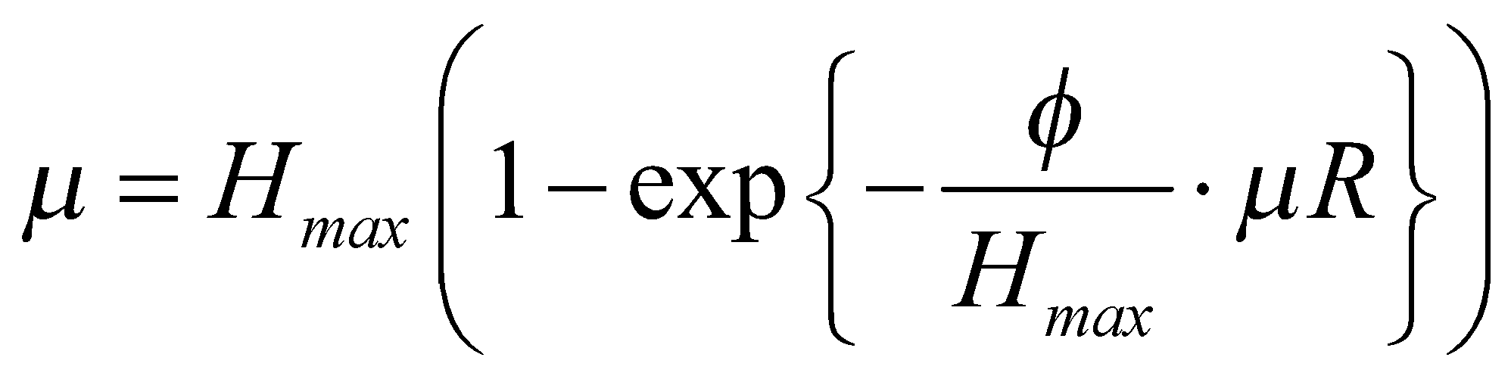 (1)
Where μR is the “true” trunk radius, H_{max} as the maximum potential height of the trees, and φ describes the initial rate of change (i.e., rate at which H changes with R for young, small trees).
The data: The data are H_{i} = height of tree i (i = 1, 2, …, 184) and R_{i,r} = trunk radius of tree i measured for r = 1, 2, and 3 repeated observations. You may want to plot the data (H vs R) to get a better feeling for the potential relationship between H and R.
The model: To define the likelihood, we will assume that tree height is normally distributed:
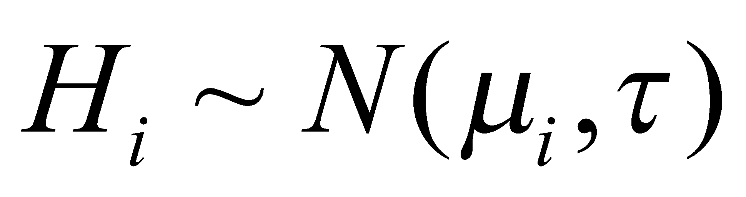 (2)
Where the mean, μ, is given by Eqn (1), and the true radius varies by tree i, μR_{i}. Assume that the repeated observations of trunk radius are normally distributed with a mean given by the true or latent radius of each tree:
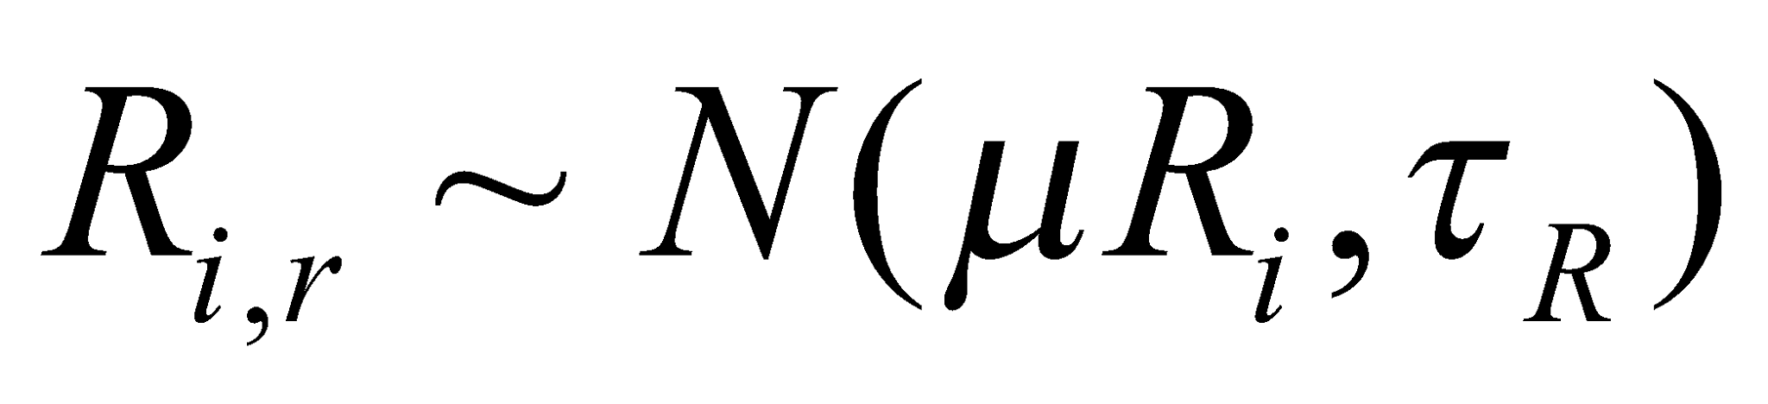 (3)
To complete the Bayesian model, assign standard, relatively non-informative priors to the allometry parameters (H_{max} and φ) and the standard deviations associated with each likelihood (e.g., σ and σ_{R}). The precisions are computed as τ = σ ^{–2} and τ_{R} = σ_{R}^{–2} (i.e., precision = 1/variance). Use the following priors:
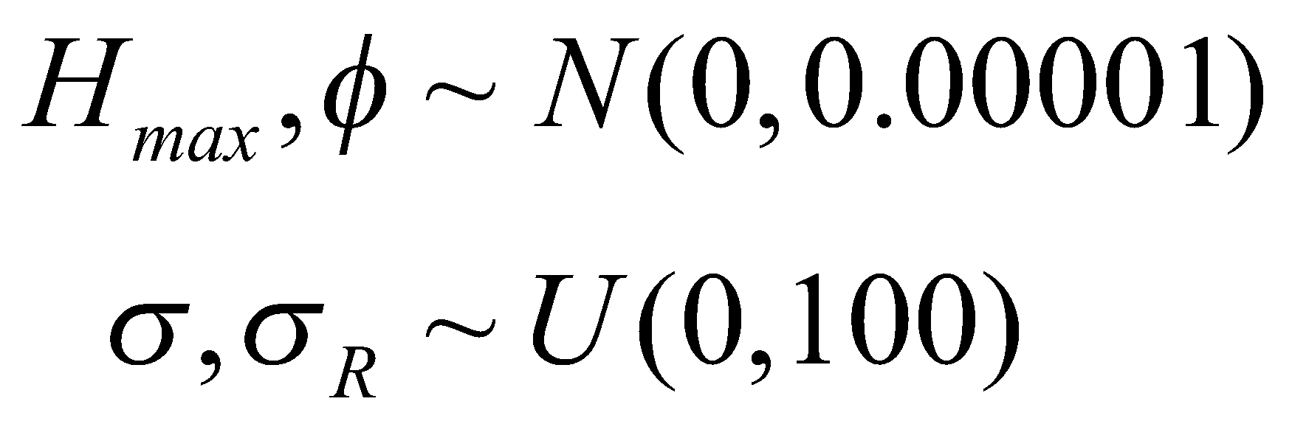 (4)
The tree-specific true radii are also unknown parameters and require a prior. Use a standard (conjugate), relatively non-informative prior for the latent radii:
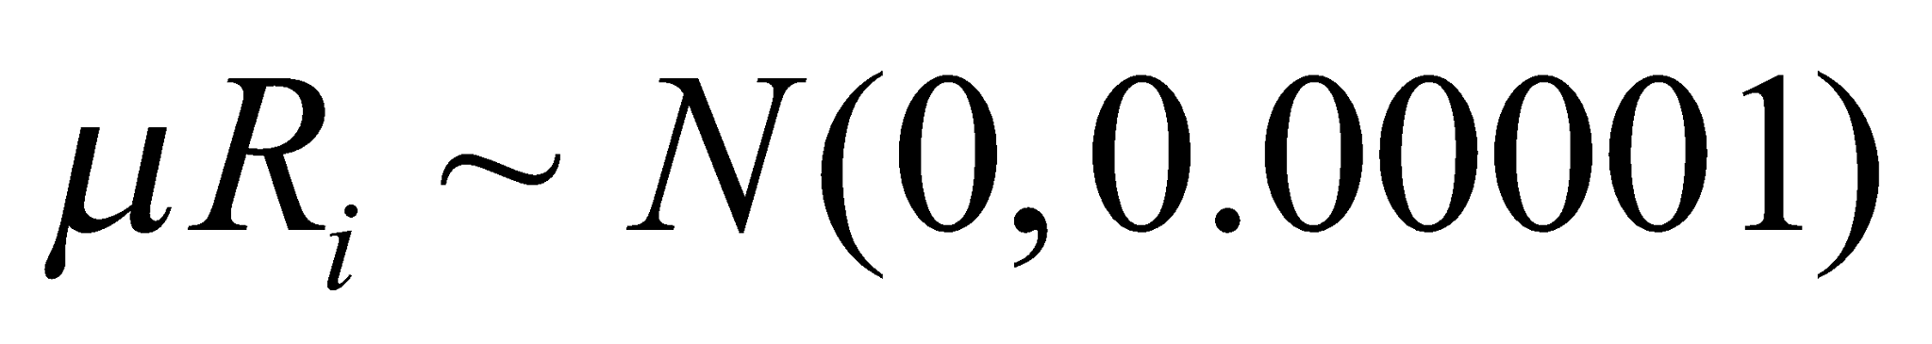 (5)
Both normal priors in Eqns (4) and (5) are parameterized in terms of a prior precision of 0.00001 (prior variance = 100,000).
Code and run the above model via R and Jags (rjags) for 3 parallel MCMC chains. You might want to provide rough estimates (initials) for the 4 parameters indicated in Equn (4) for each of the 3 chains or see if Jags can simulate initials. Evaluate MCMC behavior (mixing and convergence) and produce posterior estimates of the model parameters.
Potential extension: Assume these trees are from a plantation where four different genotypes were planted, denoted as g = 1, 2, 3, or 4. The genotype of each tree is provided in the dataset. Modify the model to accommodate “genotype effects” such that the allometry parameters (H_{max} and φ) vary by genotype. Specify a hierarchical prior that assumes that the genotype-specific parameters arises from a normal distribution described by an overall mean (e.g., μ_{φ}) and variance or precision (e.g., τ_{φ}) that quantifies variability among genotypes. Is there evidence for genotype-specific height vs radius allometries? E.g., do the allometry parameters differ among genotypes?

